Bid Documents
(RFP)
Name of Work: -Health Insurance Cover of KIU Employees Main Campus Gilgit and Sub-Campuses


Bids Issuance Date : January 06, 2026
Opening and Last Date : January 27, 2026
Opening Time : 11:30 AM
Venue : University Conference Hall

…………………………………………………………………………………………………………………………

Karakoram International University
University Road, Gilgit
Website: www.kiu.edu.pk
Email: treasurer@kiu.edu.pk/zahid.ali@kiu.edu.pk
Telephone No. 05811-960036 (Ext No.231/190) Fax No.05811-960032 (Price Rs. 5,000/-)



Bidding Document For
Health Insurance Cover of KIU employees (Tender)
Bid Should Contains the following Information / documents:

- Tender Advertisement
- Short listing Criteria
- Required Documents
- Medical Health Insurance Coverage Requirements
- General Terms & Conditions
- Bid Submission Instructions
- List of employees to be insured (to be provided on demand)
- Tender Submission Form
- Authorities
- Bona-fide Statement

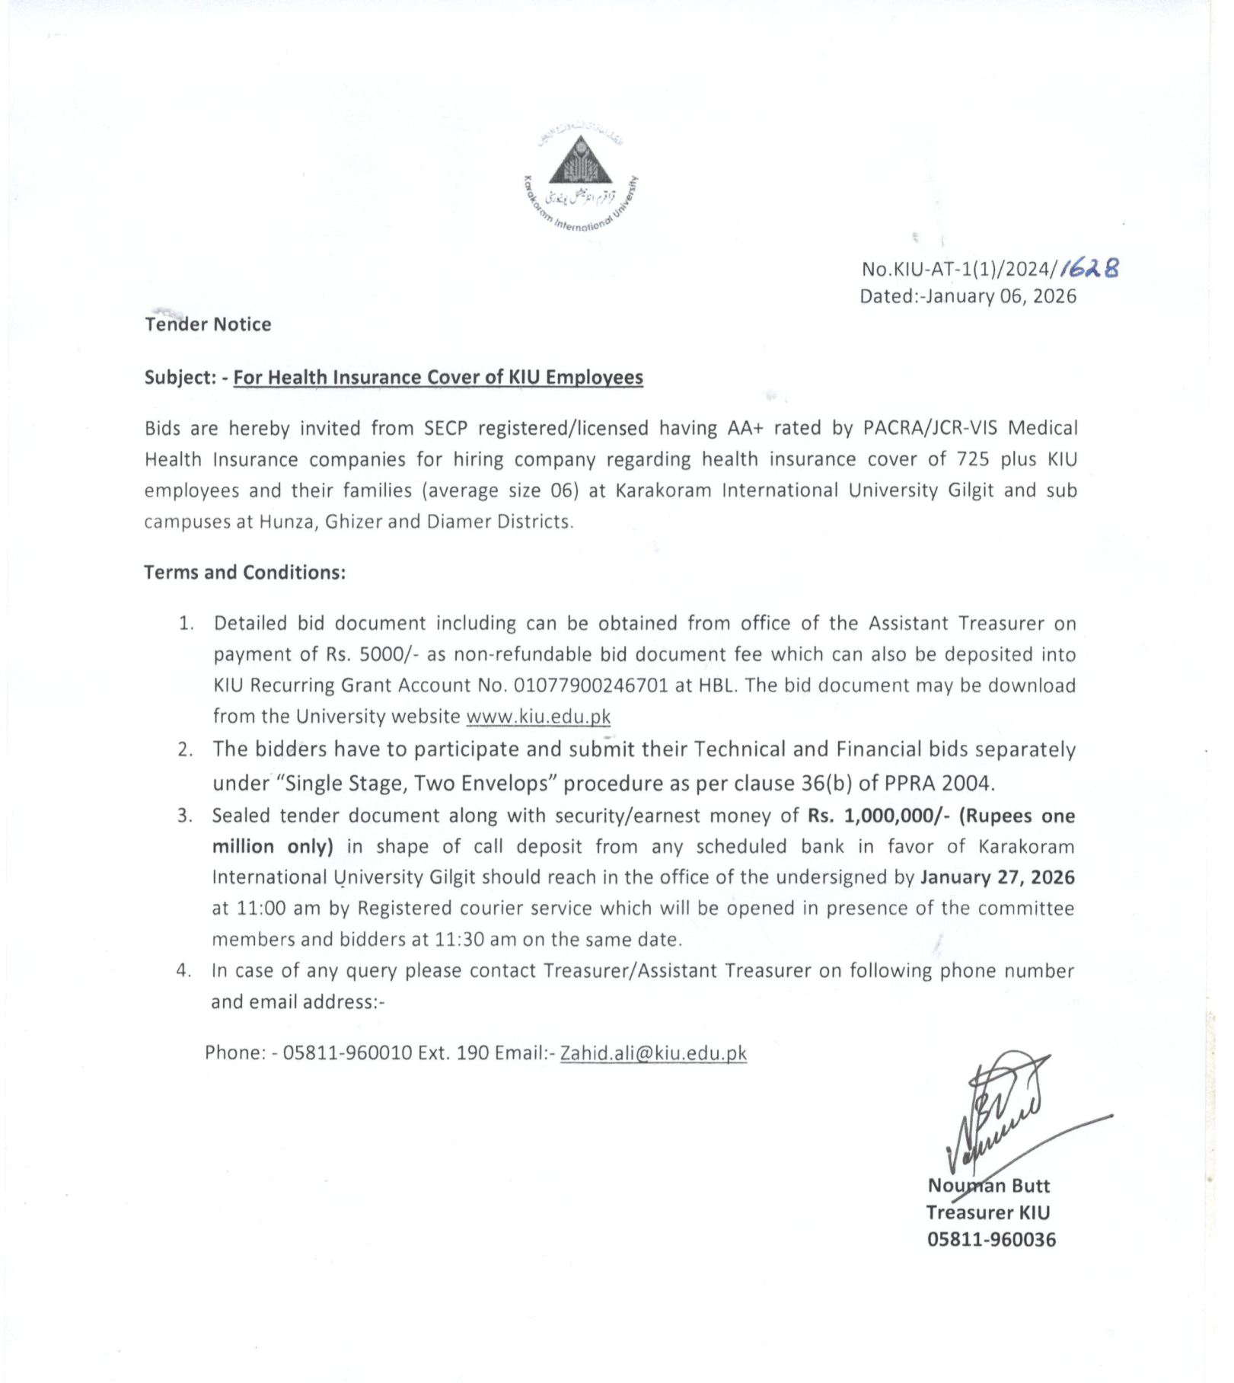

Short listing Criteria

All prospective bidders are hereby informed that following criteria will be considered for short listing the Bidders. Consequently, only short listed bidders will be considered for next stage. Note: In order to qualify for the financial Bid, bidders will be required to obtain a minimum score 60 out of 100.

A. Bidder's Profile and Strengths | Total Marks = 60
Criteria | Range | Max. Score | Score Obtained
Annual Revenue | 1.5 Billion plus  Less | 20  10
Experience | 10 years’ plus  05 years plus | 20  10
PACRA RATING  Registration with NTN/GST | 05 years’ plus  OR  05 years plus | 5  5
Registered Autonomous/Govt institutes. | More than 10  Less | 15  10
B. Benefits | Total Marks = 40
Criteria | Range | Max. Score | Score Obtained
Number of panel hospitals in Pakistan  Number of panel hospitals in GB | 30 plus hospitals  Less than 30  5 plus hospitals  Less than 5 | 15  10  10  5
Number of clients having 600 employees’ plus  Number of clients having 300-500 employees | 15-20  10-15 | 15  10
 | Total Marks = 100

Required Documents to be submitted as part of Bid submission

- Copies of registration of the Company.
- Company profile (with particular reference to project in the related business field)
- List of Board of Directors
- Bank statements for the last Three (3) years.
- Audited financial statements of Three (3) years.
- Statement that the bidder has not been blacklisted by any of the public sector regulatory bodies or others
- Membership of SECP / Trade Associations (if any)
- Rating category evidence
- List of Panel hospitals
- List of discount centers (Hospitals and Labs).
- Client list with financial strength evidence.
- List of policy exclusions.
- Performance guarantee bond /CDR of Rs. 4 million from any schedule bank or AA+ rating insurance company in favor of KIU.
- Full name of the firm, permanent addresses and number of major clients.
- Financial bid against the said services.
- Information about infrastructure of the insurance company including offices, sub offices and branches details.
- Any other information.

Medical Health Insurance Should Coverage for KIU Employees with Following Information / Requirement:

Institution’s Profile:
Name: KARAKORAM INTERNATIONAL UNIVERSITY (KIU), GILGIT-BALTISTAN
TYPE: PUBLIC SECTOR, INSTITUTION
SECTOR: EDUCATION
SIZE: SMALL SIZE UNIVERSITY
EMPLOYEES DATA:
EMPLOYEES FAMILIES AND TOTAL FAMILY MEMBERS (APPROXIMATELY)
Plan | Category 1 | Category 2 | Category 3 | Total
Categories of Employees | BPS-17 & above | BPS:11-BPS-16 | BPS:1-BPS-10
No of Employees / Family Units | 287 | 122 | 316 | 725
Total Family Members (Approximately) | 1722 | 732 | 1896 | 4350

Medical Facilities to be covered under the Medical Health Insurance

Plan: A

Description of Benefits  Hospital Care Limit | Plan-A  Category 1 Coverage | Plan-A  Category 2 Coverage | Plan-A  Category 3 Coverage
Total Hospital Care Limit (Per Family Per Year) Rs. | 800,000 | 600,000 | 400,000
Room & Board entitlement (Per day) Rs. | 15,000 | 8,000 | 7,500
Maternity Care
Normal- Rs. | 40,000 | 40,000 | 30,000
C-section- Rs. | 100,000 | 60,000 | 50,000

Plan: B

Description of Benefits  Hospital Care Limit | Plan-B  Category 1 Coverage | Plan-B  Category 2 Coverage | Plan-B  Category 3 Coverage
Total Hospital Care Limit (Per Family Per Year) Rs. | 700,000 | 500,000 | 300,000
Room & Board entitlement (Per day)Rs. | 12,000 | 7,500 | 7,000
Maternity Care
Normal- Rs. | 30,000 | 30,000 | 30,000
C-section- Rs. | 80,000 | 50,000 | 50,000

Other Terms & Conditions
Age Limit for Employees/spouses Up to 60 years, Sons up to 25 year or employed/married, Daughters till marriage or employed & parents till death or during the service of employee.
Delivery medical coverage up to 4 kids during the whole services.

Medical Health Care Plan (s) should cover:
- Hospitalization
Pre-Hospitalization Diagnostic Charges (30 days) prior to Hospitalization)
Post-Hospitalization Follow-up Charges (30 days after discharge)
Physician's Visit (In-Patient visit) Charges
Specialist Consultation (In-Patient visit) Charges
Intensive Care Unit (ICU) Charges
- Miscellaneous Hospital Expenses including:
- Surgical Operation Charges
- Day-care Surgery Charges
- Hospital Casualty Ward Accident & Emergency Services
- Should cover Specialized Investigations (Indoor-Out Patient Cover)
- (Magnetic Resonance Imaging (MRI),
- Computed Tomography (CT) Scan,
- Endoscopy.
- Thallium Scan
- Angiography)
- Should cover Treatment of Fractures & Lacerated Wound.
- Should cover Emergency Dental Treatment due to Accidental Injuries within 48 hours for pain relief only)
- Should cover Treatment for Interferon Therapy for Hepatitis B&C
- It should also cover Hospitalization Expense Benefit such as:
Any expense incurred by an insured on the non-pregnancy related hospitalization and surgical procedure due to any sickness or accidental injuries subject to a predetermined limit. There should be no restriction on number of days of hospitalization.
- Cataract Surgeries
- Hepatitis B & C Treatment (Interferon)
- Emergency Treatment (Short stay at Hospital-All emergencies except OPD should be covered under Hospitalization Care Limit).
- Angiographic all types etc...

- It should cover Pre & Post Hospitalization Expense Benefit including:
Pre & Post hospitalization benefit should be available within the basic hospitalization limit for a maximum of 30 days before or after the (non-pregnancy related) hospitalization to each family insured per confinement.
- Pre & Post hospitalization limit should be available for the following treatment, which is directly related to the cause of hospitalization:
- Consultants fee in the follow up visits
- Cost of medicines & supplies
- Cost of Lab tests
- Dressing charges and stitch removal
- It should cover Advance Comprehensive Dread Disease Expense Benefit including: -
Following dread diseases, which cause heavy inpatient treatment expenses should be covered under the Medical Health Insurance Plan (s): -
- Stroke (Cerebro-vascular accident)
- Coronary Artery by-pass grafting & Angioplasty
- Knee Replacement & Hip Bone Replacement( without the cost of prosthesis) Cancer Treatment & Chemotherapy — Malignant disorders
- Kidney Failure
- Major Burns
- Major accidents, multiple Fractures & head injury
- Major Organ Transplant (Cost of surgery)
- Aplastic Anaemia
- Accidental Blindness (Loss of Sight)
- End Stage Lung Disease
- Multiple Sclerosis
- Muscular Dystrophy
- Parkinson Disease
- Alzheimer’s Disease / Severe dementia
- End Stage Liver Failure Chronic
- Hepatitis B & C / Fulminant Hepatitis
- Liver Cirrhosis
- AIDS complexity
- Aortic Aneurysms
- Rheumatic Heart Diseases
- Paralysis
- Brain Tumor
- Other Cancer diseases
- Diabetes
- Hernia
- Medical Health Insurance plan should cover Advance Specialized Investigations including: -
  - CT Scan
  - ERCP
  - Nuclear Scans
  - Angiographies all types
  - Mammography
  - Doppler Sonography
  - Echocardiography
  - Upper+ Lower GI Endoscopies
  - ETT (Exercise Tolerance Test
  - E.E.G (Electro Encephalography)
  - ECG

- Maternity Care Benefit:
The maternity Expenses should consist of antenatal expenses (Expenses on consultation, lab test, medication etc. before delivery). Delivery Expenses (Expenses on delivery, normal or otherwise) and post-natal expenses (Expenses occurring up to 21 days after and related to the pregnancy including: -
    - Pre & Post-natal expenses.
    - Gynecologist's fee.
    - Labor Room & Operation theatre charges.
    - Anesthetist fee.
    - Medicine
    - Diagnostic tests.
    - Baby Nursing Care.
    - Circumcision of a baby boy (as per policy).
    - D&C
    - Cesarean Section and Complicated Deliveries/Pregnancies by and on recommendation of specialist only.

General Terms & Conditions:

A. Financial quotation should be inclusive all sort of taxes.
B. A firm/company in the same field having at least 05 years experienced may participate in the Bid.
C. Only those insurance firms may participate in the bid which are dealing with Medical Health Insurance with respect to Per Family Medical Health Insurance Coverage only.
D. The Insurance Companies having AA+ rating should participate.
E. The bidders have to participate and submit their Technical and Financial bids separately under “Single Stage, Two Envelops” procedure as per clause 36(b) of PPRA 2004. Financial bids of only those shortlisted firms will be opened whose technical bids are accepted by the technical committee.
F. Validity of the proposal must be for three months (90 days) from the date of issue.
G. Ambiguous, conditional and void bids are liable to be rejected.
H. KIU reserves the right to reject/cancel the tender as per clause 33 of PPRA 2004.
I the bidder must attached earnest money Rs 1,000,000/ one million only with technical bid in shape of call deposit from any scheduled bank in favor of Karakoram International University Gilgit should reach in the office of the under signed by January 27, 2026 (11:00 AM) by registered courier which will be open in presence of the committee members and bidders at 11:30 AM on the same date.
J. The Insurance Companies has to quote Medical Health Coverage Insurance Premium for each Plan separately and in total.
K. The Insurance Companies has to quote Medical Health Coverage Insurance Premium / cost per family / per plan for information of the client.
L. Any other necessary information or conditions should be specifically mentioned in the bid.
M. In case if shortlisted the concerned insurance firms has to arrange a presentation for satisfaction of the client.
N. In case of selection an MoU will be executed as per policy.
O. Tenders received after due date and time will not be entertained at any cost.
P. KIU encourages the legal business in the country so only NTN & GST registered Firms may participate in the Bidding process.
Q. Financial invoices will be included all sort of taxes, KIU will not bear any kind of tax.
R The validity period of the bid shall be 90 days.
S. Payment will be made in four quarters in advance of each quarter subject to satisfactory performance. First installment will be paid upfront.
T. The decision of the university shall be binding on all concerned and will in no case be challengeable
at any forum or any court of law.
U. Performance guarantee\bond of Rs. 4 million from any schedule bank or AA+ rating insurance
company in favor of KIU (only by the successful bidder before signing of agreement) .
V. KIU may opt any of above two slabs/option subject to its budget and premium.
W. Chronic diseases will be covered through corporate pool fund of Rs. 3,000,000/-(Three million only) lump sum. The fund may be used by the university for any other coverage.
X The bidders are required to submit financial bids for Option A and Option B separately .
X. The decision of the university shall be binding on all concerned and will in no case be challengeable at forum or any court of law.

Bids’ Submission instructions:

Bidders are required to follow the following instructions:

- Any offer not received as per Terms and Condition for the tender enquiry is liable to be ignored. No offer will be considers if: -
  - Received without earnest money from unregistered firm or a firm not registered for the item / service mentioned in this tender.
  - Received after the time and date fixed.
  - The tender is unsigned.
  - The offer is ambiguous.
  - The offer is conditional.
  - The offer is from a firm blacklisted, suspended, or removed from the approved list.
  - The offer is not submitted on bid document.
  - Offer received from shorter validity than required in the tender enquiry and

- Offer will remain valid for 90 days from the date of opening the tender.
3. Successful bidder will have to provide services immediately.
4. In the case the offer is withdrawn, amended or revised during the validity period of the order, the earnest money is liable to be forfeited.
5. Other GENERAL INSTRUCTIONS: -
- Tender should be addressed to the Treasurer, KIU, Gilgit.
- Tender should be quoted final rates both in word as well as in figures.
- Any condition, ambiguous or called incomplete offer in any respect shall be ignored. No supplementary or revised offer after the opening of tender shall be entertained.
- The tender should specifically indicate their G.S.T. No. and Sales Tax No.
- Any erasing / cutting / crossing etc appearing in the offer must be properly signed by the person signing in the tender. Moreover, all pages to the tender must also be properly signed. Offer with any over-writing shall in no circumstances be accepted.

Tender Submission Form

(Applicant’s Internal Official Letter Number………………………………..…)

To,

The Treasurer
Karakoram International University
Gilgit City, Gilgit-Baltistan

From,

………………………………………………….,

SUBJECT: Tender Submission for Health Insurance

Dear Sir,
It is submitted that our organization ……………..…………………………………..….is interested to participate in the Bidding process of Health Insurance advertised by your Organization in the PPRA MIS and official website. It is further stated that our organization is fully competent and fulfill your requirements as per your Bidding Document. Detail of our representative is as under:

Authorized person: ……………………………

Signature: ……………………………………..

Dated: …………………………………………

Authorities:

ON BEHALF OF KIU

Authorized Person: …………………………………………………….

Designation: ……………………………………………………

Seal:

ON BEHALF OF TENDER SUBMITOR

Authorized Person: …………………………………………………….

Designation: ……………………………………………………

Seal:

Bona-fide Statement by the Bidder

I hereby declare that the information and particulars furnished above by my office are true. I further declare that if any of the above particulars or information is found by the company to be inaccurate or false in any respect whatsoever, my Tender before or after the acceptance may be canceled and the whole process may be considered void ab-initio.

Authorized Signature.

Director Finance, Finance Department

Karakoram International University (KIU), Gilgit

